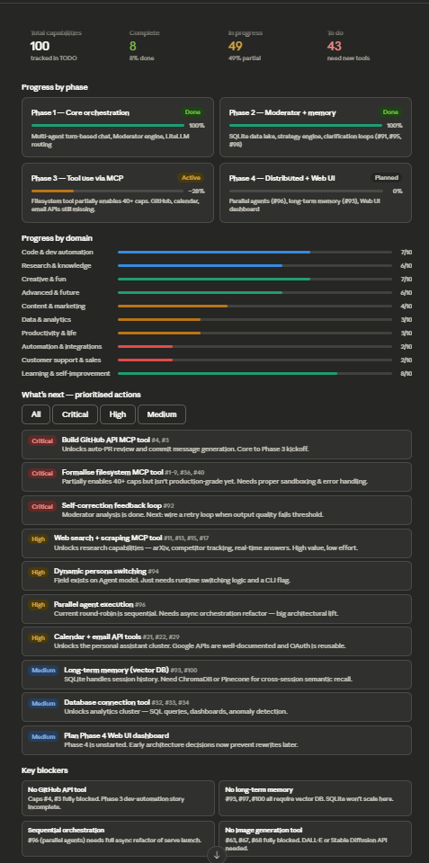
Now let me dig into the key files — the TODO list, RELEASE notes, and the Skimatics folder (likely "Schematics"):Good — I have enough context. Let me now build the full audit dashboard.Now I have everything I need. Let me build the audit dashboard:Here's a full audit of your repo. Let me break down what I found:
Current state: Phases 1 and 2 are fully complete — the multi-agent orchestration, Moderator engine, SQLite data lake, and clarification loops are all solid. You're mid-Phase 3 with a partially-wired filesystem tool that's doing a lot of heavy lifting for the "in progress" items.
The critical path to unlocking the most capabilities:
The single highest-leverage move is formalising the filesystem MCP tool properly — it's already partially enabling ~40 capabilities but likely isn't hardened. Right after that, adding a GitHub API tool completes the dev automation story (#4 PR reviews, #3 commit messages) and is probably the most "impressive" demo capability you're missing.
The architectural debt to address before Phase 4: The serve launch command is still sequential round-robin. Capability #96 (parallel agents) requires an async refactor, and that refactor will touch the same code as the Phase 4 Web UI. Better to design for it now than rebuild later.
Quick wins hiding in "todo": Dynamic persona switching (#94) is almost done — the persona field already exists on the Agent model, it just needs a runtime flag. That's probably an afternoon of work.
You can click any row in the "What's next" section to have me help you implement it directly. What would you like to tackle first?

